What's Inside this Guide:

Inpatient Summary MPage

Overview

Configuration

©2009 Cerner Corporation

All rights reserved. This material contains the valuable properties and trade secrets of Cerner Corporation of Kansas City, Missouri, United States of America (CERNER) embodying substantial creative efforts and confidential information, ideas and expressions, no part of which may be reproduced or transmitted in any form or by any means or retained in any storage or retrieval system without the express written permission of CERNER.

Cerner believes the information in this document is accurate as of its publication date. While Cerner has made a conscientious effort to avoid errors, some may still exist. The information in this document is subject to change without notice, and should not be construed as a commitment by Cerner Corporation.

The following are trademarks of Cerner Corporation: CapStone; Care Designs; CareNet; Cerner; Cerner APACHE; Cerner HealthSmart; Cerner Millennium; Cerner Multum; Cerner ProVision; Cerner’s logo; CVNet; Discern; Discern Expert; Discern Explorer; EasyScript; Executable Knowledge; FirstNet; Health Facts; Health Knowledge Arcclickecture; Health Network Arcclickecture; HNA; HNA Classic; HNA Millennium; INet; InfraNet; Intellistrip; IQHealth; MedNet; MillenniumObjects; MRNet; OCF, Open Clinical Foundation; Open Engine; OIF, Open Image Foundation; Open Port; PathNet; PharmNet; PowerChart; PowerChart Office; PowerLink; PowerOrders; PowerVision; ProCall; ProCure; ProFile; ProFit; RadNet; and SurgiNet. All other trademarks referenced herein are the property of their respective owners.

Table of Contents

Inpatient Summary Overview 4

Build Overview 4

Cerner Bedrock Wizard 4

Prefmaint Build 5

# Inpatient Summary Overview

This *M*Page is focused on providing a general summary for patients with the encounter type of "Inpatient". The page integration with the Cerner Bedrock Wizard allows for page layout customization that defines what content displays on the page, and how that content displays. The Inpatient Summary *M*Page has 14 components available to display on the output in this release.

The following is the list of the components that are available:

* Patient Information
* Diagnoses
* Problems
* Allergies
* Medications
* Vital Signs
* Measurements and Weights
* Intake and Output
* Diagnostics
* Microbiology
* Laboratory
* Pathology
* Documents

# Build Overview

There are several tools that will need to be leveraged to build/configure this MPage.

* Cerner Bedrock Wizard
  + Configure which sections that display and the order of sections
  + Configure appearance of sections
  + Select which data elements qualify for display in sections
* Prefmaint
  + Add the tab for positions

# Cerner Bedrock Wizard

The Bedrock Wizard is the main configuration tool for the Inpatient Summary *M*Page. The following steps provide the basic foundation to perform the Inpatient Summary *M*Page setup.

1. Open the Bedrock.exe application.
2. Select the Quality Reporting and *M*Page Setup link  
   NOTE: If this link is not available, it will need to be added via the Bedrock Wizard Security, by configuring access to the Quality Reporting and MPage Setup.
3. Select the *M*Page Setup link from the *M*Page Solution.
4. In the topic dropdown, select Inpatient Summary.
5. On the parent Inpatient Summary component, select the Define *M*Page layout button to determine which sections display, and the order of those sections.
6. After the sections to display are determined and the page layout is defined, complete the necessary filters for each section.

Once the Bedrock Wizard setup is complete, the Discern Report tab needs to be added to the necessary applications.

# Prefmaint Build

In prefmaint.exe, add the tab Discern Report tab the necessary positions and set the following preferences:

View_Caption -> Whatever you want the tab to be named.

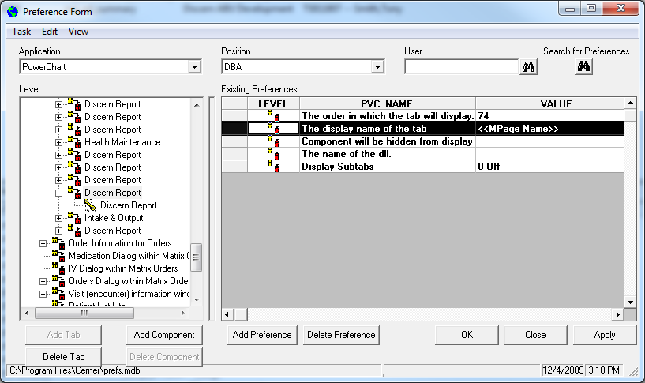

REPORT_NAME-> mp_inpatient_summary

REPORT_PARAM-> "MINE”

